Sweet potato, carrot, orange and ginger juice

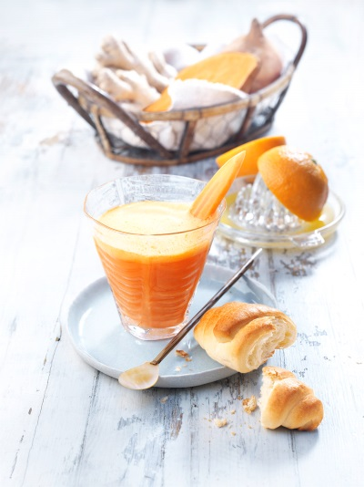

Ingredients for 4 juices à 200 ml :

600 g sweet potatoes from North Carolina
600 g carrots
40 g ginger
2 oranges
2 limes
1 TL nut oil

Directions:

- Peel sweet potatoes, carrots and ginger. Put all ingredients in a juicer. Squeeze the citrus fruits and blend with juice and oil.

Nutrition facts per glass:
Energy: 210 kcal/880kj
Protein: 4 g
Fat: 4 g
Carbohydrates: 41 g

