Sweet potato cabbage salad with ginger

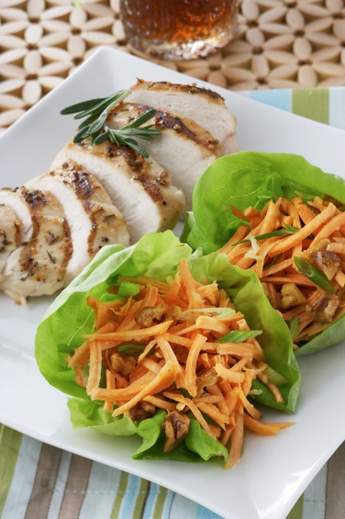
Ingredients (6 servings):

700 g sweet potatoes from North Carolina
6 tbsp rapeseed oil
6 tbsp lime juice
1 1/2 tbsp sugar
1 1/2 tsp fresh ginger, grated
1/2 tsp salt
60 g roasted walnut pieces
1 spring onion
Salad leaves to serve

- Mix oil, lime juice, sugar, ginger and salt.

- Chop the spring onion into small pieces. Cut sweet potatoes into thin strips and mix with walnuts, spring onion and dressing.

- Chill before serving. Serve on salad leaves. It goes well with fried chicken breast.

Preparation time / working time (without waiting time): approx. 45 minutes.

Nutrition per serving:
Energy280 kcal/1170 kJ
Protein4 g
Grease15 g
Carbohydrates31 g

