Rainbow salad

Ingredients (4-6 servings):
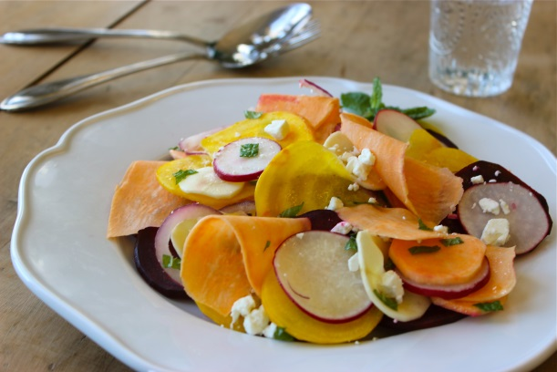

2 small sweet potatoes from North Carolina
6 tablespoons olive oil
3 tablespoons lemon juice
1 tsp honey
1 small garlic clove
1/2 tsp salt
1/4 tsp black pepper
1 medium yellow beetroot (red beetroot as an alternative)
2 smalls parsnips
1/2 small red onion
6 radishes
15 g fresh mint
1 small beetroot
100 g feta cheese

1. In a large bowl combine oil, lemon juice, honey, garlic, salt and pepper.

2. Peel the vegetables and (except for the beetroot) cut them into thin slices with a slicer. Chop the mint into small pieces. Put the dressing and mint over the vegetables.

3. Peel beetroot, cut into fine slices and arrange on a plate. Put salad on top and sprinkle with feta cheese.

Nutrition facts per serving:
Energy 200 kcal/840 kJ
Protein 8 g
Fat 13 g
Carbohydrates 12 g

