Grilled sweet potato salad with beef steaks

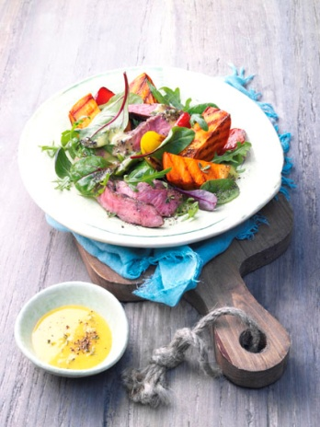
Ingredients for 4 servings:
600 g sweet potatoes from North Carolina
1 tsp medium hot mustard
4 tablespoons orange juice
6 tablespoons olive oil
½ Thyme bunch
1 yellow pepper (approx. 170 g)
1 red pepper (approx. 170 g)
250 g baby leaves (salad mixture)
2 beef steaks (250 g each)
Oil for the grill rack
Salt
Aluminium Foil

Directions:

1. Cook sweet potatoes for 20 minutes. Meanwhile mix mustard, orange juice and ½ teaspoon salt. Stir in olive oil bit by bit. Wash the thyme, shake dry and pluck leaves from stems.

2. Wash and dry bell peppers. Quarter them and cut out the core. Wash salad and spin dry. Drain the sweet potatoes, leave to cool and peel. Halve lengthwise and cut into slices.

3. Season steaks with salt and pepper. Coat the grill with oil. Grill steaks on the hot grill from each side for 3 - 4 minutes. Wrap in aluminium foil and let rest for 10 minutes. Meanwhile grill potatoes and peppers while turning. Mix the potatoes and vegetables with the vinaigrette. Cut the steaks into fine strips and add to the potatoes together with the salad. Mix everything well and serve.

Preparation time: ca. 1 hour

Nutrition facts per portion:
Energy: 488 kcal / 2040 kJ
Protein: 31,4 g
Fat: 20,6 g
Carbohydrates: 42,8 g

